***Topic- Hate Crime Data Analysis in Austin (2017–2024)***

**SID No: 740082678**

**INDEX**

* **Introduction 2**
* **Dataset Overview 3**
* **Methodology 5**
* **Exploratory Data Analysis (EDA) 5**
* **Statistical/Analytical Methods 8**
* **Visualization and Key Findings 10**
* **Recommendations 13**
* **Conclusion 15**
* **Reflection on Project Experience 16**
* **Appendices 18**
* **References 19**

**Introduction**

Hate crimes are violent acts founded upon profound prejudices against victims on the basis of their race, religion, gender, sexual orientation, handicap, and other identifying characteristics. The acts create distrust, engender fear, and foster division in the community. Hate crimes are a persistent issue of concern for society that necessitates timely evaluation and action. Austin is one of the culturally diverse cities that have been growing very rapidly.

This report will analyse hate crimes happening in Austin between 2017 and 2024, considering the following questions:

* What prejudices lead to hate crimes in Austin?
* How have the frequency and distribution of these crimes changed during this period?
* Where do these crimes take place?
* What are the demographic characteristics of victims and perpetrators?
* How might forecasting models indicate trends for setting policies?
* Advanced analytics were used to study the following questions:
* EDA: Identifies temporal, geographical, and demographic patterns.
* Regression Modeling: Finds the relationship between the variables; it will show how the demographic variable affects the variation in the pattern of crimes.
* ARIMA Forecasting: Predicts the future trend of hate crime for resource allocations and mitigation of risk.
* Geospatial Mapping: It shows the hotspots for interventions.

This goes beyond a mere academic review to the provision of findings that are useful for all stakeholders in efforts towards reducing hate crimes. The results can help policymakers, chiefs of police, and civic leaders in framing specific interventions, adequately distributing resources, and encouraging dialogue about the most effective practices that will provide solutions to reduce systemic bias.

The following report brings together statistical analytics, visualizations, and predictive modelling to shed light on current trends in hate crime, developing practical recommendations for its prevention. It concludes with specific proposals for stakeholders on how to address high-risk areas, protect vulnerable communities, and promote social cohesion.

By integrating statistical analysis with real-world policy execution, this project has made safety more approachable for the whole town of Austin. This project tends to shape a community free from fears and discrimination either by consolidating the patterns or motivation driving hate crimes.

**Dataset Overview**

This analysis leverages the hate crimes reported to the Austin Police Department dataset, from 2017 through 2024. This dataset contains incidents that meet the federal, state, and FBI definitions of a hate crime. Some of the variables of note include:

* Location of offense - examples: street or park
* Bias Type: Description of reason for crime: race, religion, or gender.
* Date: Incident or reporting date.
* Victims/Offenders: Counts for each incident.
* District Code identifies council districts.
* Offenders' demographics: race/ethnicity.
* Analyse the event patterns by day of the week.

These variables form the basis for analysing hate crime patterns by geographical, demographic, and temporal dimensions.

**Data Cleaning-**

To ensure data reliability, the following cleaning was done:  
1. Missing variables: Missing location variables were replaced with "Unknown", zip codes were converted to string format, and the mean of missing council district values was provided. Additionally, the missing variables for the offender's race and ethnicity were changed to "unspecified."  
2. Dates Validation: All dates fell between 2017 and 2024.  
3. Entries Standardization: Combine similar categories such as "African-American" and "Black."  
4. Deduplication: Removed duplicate records.  
5. Day of the Week Extraction: We extracted the day of the week from the date field.

**Ethics, Security, and Privacy-**

The use of the dataset follows high ethical standards

1. The dataset is used with strong ethical standards. To protect sensitive data, personal identifiers are no longer anonymized or pseudonymized.
2. Bias Mitigation: Missing or incomplete demographic data were replaced with neutral placeholders such as "Unspecified."
3. Reinforcing Bias Avoidance: Insights shall be more inclusive, with a deep understanding of the limitations of data.

One of the major disadvantages of underreporting is observed in the underserved sections, thus hampering the capacity of the dataset to reflect the true extent of hate crimes. The study has thus emphasized the trend and pattern instead of absolute numbers.

**Challenges in the Dataset -**

Key challenges include:

1. Data Consistency: Regular updates may cause discrepancies between reports.
2. Underreporting: Marginalized groups and certain bias types are less likely to report incidents.
3. Bias in Classification: APD's interpretation of hate crimes may differ from public perception.
4. Incomplete Demographics: Missing offender or victim data introduces potential analysis bias.
5. Temporal Gaps: Reporting lags or incomplete records can obscure seasonal patterns.

**Methodology**

**Exploratory Data Analysis (EDA)**  
This research work has used EDA and advanced analytical techniques to extract trends, patterns, and meaningful insights about hate crimes reported in Austin between 2017 and 2024. Temporal, geographic, and demographic dimensions were focused on to present comprehensive insights into the distribution of hate crimes.

**Analytical Techniques**

1. A graph with a line going up

   Description automatically generated**Time-Series Analysis**-  
   A time-series analysis was performed to study the trends in hate crimes from 2017 to 2023. The data indicated a rising trend and that events peaked in 2023. Some of the results, such as the sharp increase after 2020, were related to potential societal or political factors that could be causing these patterns. This method serves as the foundation for predicting upcoming accidents and was required to find long-term trends..
2. **Categorical Analysis**-  
   Bias-specific distributions were analyzed to identify disproportionately targeted groups. Anti-Black or African American incidents were most frequent, followed by Anti-Gay (Male) and Anti-Jewish categories. Emerging categories, such as Anti-Hispanic or Latino and Anti-Transgender biases, were also observed.

This analysis was critical for highlighting vulnerable communities and informing targeted interventions.

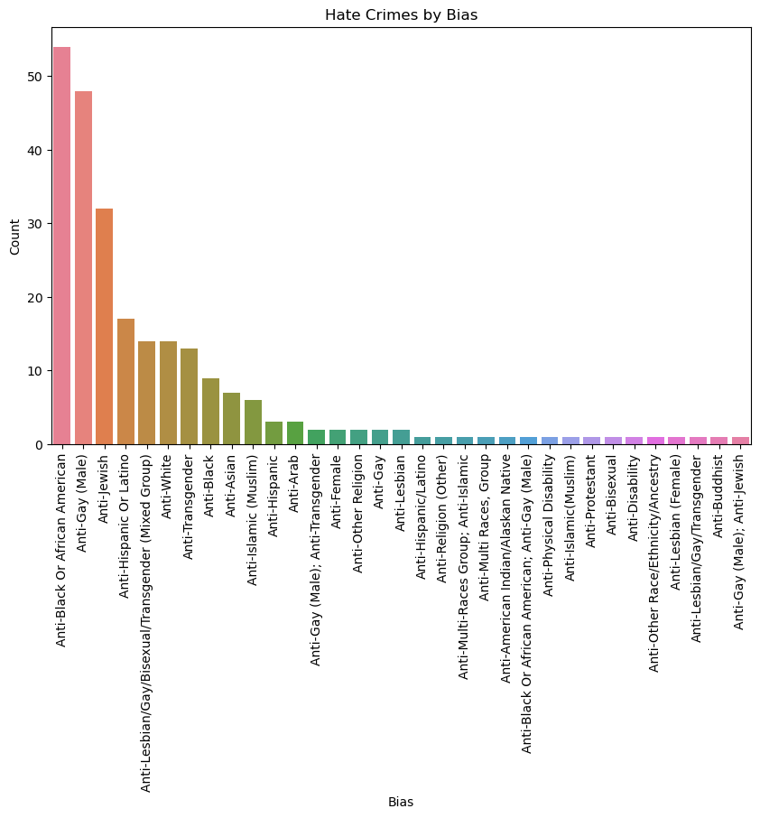.

1. **Comparative Analysis**-  
   A comparative ranking of the top 10 zip codes with the most incidents revealed a pattern of vulnerability in specific neighborhoods. These findings provide actionable insights for targeted resource allocation, including increased law enforcement patrols and community engagement.

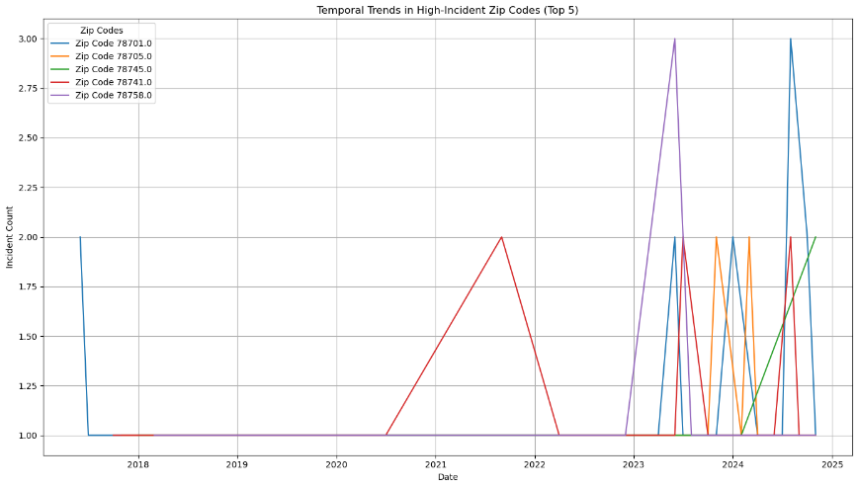

1. **ARIMA Forecasting**-  
   ARIMA modeling was employed to project future trends in hate crimes. This approach offered precise short-term predictions and highlighted the potential for continued increases in incidents. ARIMA was chosen for its reliability in time-series analysis, though it requires careful handling of missing data and consistent trends for accuracy.

**Tools and Techniques**

The analysis was conducted using a combination of tools:

* Python Libraries: Pandas for data manipulation, Matplotlib and Seaborn for visualizations, and Statsmodels for ARIMA forecasting.
* Excel: Used for initial data validation and ensuring data integrity.

**Technique Justification and Limitations**

• Justification of Models:

ARIMA was chosen because of its precision in modeling the trends and anomalies in time series data. For geographic and categorical analysis, visual aids were used to draw out disparities and vulnerable groups effectively.  
• Alternative Methods Considered:

Other forecasting methods, like exponential smoothing, were considered but discarded since most of the trends in this dataset were linear.

• Assumptions and Limitations:

• Imputed missing data for categorical variables (race/ethnicity) may introduce bias.  
• Simplifications in geographic and demographic groupings may obscure nuanced insights.

• ARIMA assumes consistent trends, which could limit accuracy in highly volatile datasets.

**Statistical/Analytical Methods**

**Heatmap Analysis:**  
A heatmap intuitively visualizes the correlations between important variables. Color intensity is determined by strength and direction of the correlations:

• Red Shades: Reflect positive relationships. For example, victims and offenders being over 18 shows a moderate positive relationship between these factors.

• Blue Shades: Represent negative associations; for example, there could be a slight negative association between victims and offenders who are less than 18 years old.  
  
• Neutral Shades: Depict negligible or very weak associations near zero.

The diagonal values are the self-correlation, which is consistently 1. The heat map, by emphasizing patterns-preferably demographic trends, guides focused interventions, and thus makes data interpretation rather easy.

**Regression Analysis:**  
Regression modeling was treated by event counts as a dependent variable and years as the independent variable to capture a linear increase in hate crimes incidents.

Among the most relevant findings are:  
• Trend Analysis: The high R-squared value and significant positive correlation proved the event trend to be non-random but rather systematic.

• Predictive insights: By quantifying how much hate crimes have risen per year, the regression line showcased the urgency of taking preemptive measures

.  
• Key Takeaways: Periods of high growth were unveiled, and such a scenario demands interventions aimed at those very factors responsible for this trend.

Since it was assuming steady growth, the linearity of the regression model could not handle such sudden, unexpected shifts, although it was reflecting the long-term trend.

**3. Visualization and Key Findings**

**3.1 Trends Over Time**

**Annual Trends:**

This is an upward trend in hate crimes from 2012 through 2021, increasing from 50 incidents in 2011 to 78 in 2021. There was a significant jump between 2014 and 2016 when incidents increased by more than 10 counts. The projection into the future shows that there will be a levelling of approximately 80 incidents annually in the future, which would represent a possible stabilization. This is a steady increase in the last ten years and might imply that it is a growing concern and could be linked to either societal or political factors.

**Monthly Patterns:**

There is a marked difference in the incidents of hate crimes that occur in the different months.  
• November stands out as the month with the most incidents at over 30.  
• June and August follow closely when the cases are about 30 and 28, respectively.  
• February and May record the lowest incidence, ranging between 10-12 cases.  
The increase in incidents in November may be attributed to increased social or political activities, while the summer months of June to August may indicate public events or increased activities during that period.

**Seasonal Patterns:**  
Seasonal trends are indicative of well-defined patterns of highs and lows:  
• Hate crimes rise sharply in summer (June-August) and late autumn (November).  
• Fewer cases are recorded during winter-February and late spring-May.  
This is a seasonal trend that perhaps could reflect outdoor public events, communal gatherings, and holiday seasons that heighten social interaction and can develop into incidents.  
**Day of the Week Trends:**  
• Sundays and Saturdays show the highest incidence of hate crimes, peaking at 47 and 44 incidents, respectively.  
• Mid-week days, such as Tuesday and Thursday, experience the lowest activity, around 27–35 incidents.  
The higher frequency of hate crimes on weekends suggests increased public interactions, gatherings, or nightlife activities.

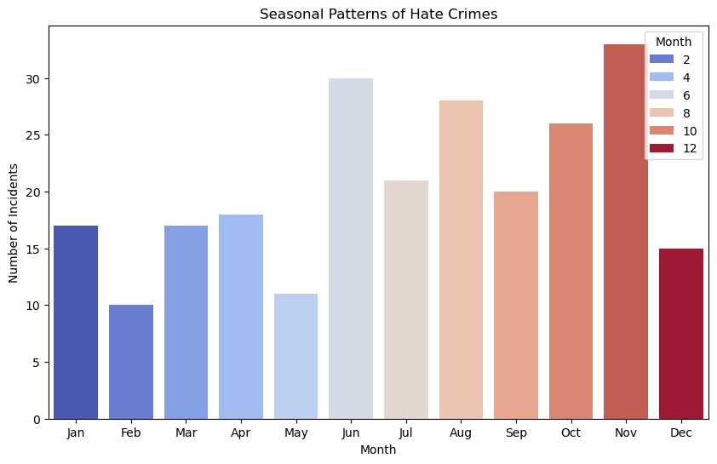

**3.2 Most Common Offenses**  
The pie chart shows the share of various offenses that have contributed to hate crimes. Key observations include:  
• Assault is the highest type, making up 40% of all incidents.  
• Theft follows, comprising 30% of reported cases.  
• Robbery makes up 20% and burglary is the least frequent bias-related offense by 10%. This distribution indicates that assaults are the leading type of hate crime, thus showing a concentrated interest in causing physical harm or intimidation.

**3.3 Ages and Bias**

The bar graphs show that anti-Black incidents occur the most frequently, followed by anti-Gay and anti-Jewish incidents. This demonstrates that systemic racial and LGBTQ+ biases are serious issues. Adults over 18 are overrepresented, demanding targeted treatments. These findings emphasize the need for focused awareness programs. These issues must be addressed if the community is to become more welcoming and safe.

**Recommendations**

Any successful effort to prevent hate crimes in Austin must be multidimensional, taking into account hotspot locations, prejudice tendencies, and demographic variances. Here are some proposed measures:

**1. Targeted Policing in Hotspots**

* Increase law enforcement resources in high-risk regions with a high frequency of hate crimes, such as 78701-Downtown, which is more prone to incidents because of the high traffic, public meetings, and nightlife.
* 78705, 78741, and 78745: diverse demography, residential, mixed-use zones with lively public places.  
    
  Action Steps:
* Provide more frequent patrols at the periods of highest risk: weekends in June/November.
* Liaise with local businesses and community leaders to improve surveillance and crime prevention measures in hotspots.

**2. Community Engagement Programs**

Encourage dialogue and understanding among diverse cultures as a means of reducing tensions and resolving underlying prejudices.

Actions Needed:

Organize community forums, workshops, and cultural exchange programs to promote inclusivity and reduce bias.  
  
Organize school, university, and youth organization networks to promote tolerance and respect. In dealing with local concerns, create task forces consisting of law enforcement, community leaders, and marginalized groups.

**3. Awareness Campaigns**

Establish a network of organizations at the youth, college, and school levels for the promotion of respect and tolerance.

Organize law enforcement task forces, community leaders, and representatives from the disenfranchised groups to deal with the problems at the local level.  
  
With concentrated education and media efforts, the two most common biases—against gay men and in favor of Blacks or African Americans—can be reduced.

Actions to Take:

To increase awareness, utilize publicized media campaigns, grassroots efforts, and social media. Devote specific times of the year, such as Pride Month in June or significant political and cultural events, to outreach and education.

**4. Policy Interventions**

Additionally, bolstering legal procedures and structures guarantees victims of hate crimes prompt justice and discourage criminals.  
Steps to take include:

• Examining and improving hate crime laws to provide victims with a clear definition, harsher punishments, and equitable justice.  
• Fast-track judiciary mechanisms to reduce delays in conducting the prosecution of hate crime cases.  
• Provide the victim with the necessary legal and psychological assistance for their rehabilitation and seeking of justice.

**5. Data-Driven Monitoring**

Employ data analytics to track trends, assess action, and get ahead of new hate crime trends.  
Actions to Be Taken:

• Development of a current, integrated crime dashboard of crimes, by victim demographic, geography, and type of bias.

• Use predictive analytics to find the high-risk regions and times to proactively deploy law enforcement resources.

• Conduct the required routine evaluations and assessments to gauge the effectiveness of the measures implemented for ongoing development.

**Conclusion**

This research offers a data-driven perspective on hate crimes in Austin, highlighting significant geographic hotspots, temporal patterns, and demographic characteristics. These findings indicate a significant concentration in areas such as zip code 78701, which is disproportionate for the Black or African American and LGBTQ+ (Anti-Gay Male) populations. The increases in June and November show how geopolitical events, cultural festivities, and increased public involvement affect bias-motivated violence. To address these challenges, a multi-pronged strategy is essential:

**Targeted Interventions:** Law enforcement actions in high-risk locations, such as increased patrols and community policing, may help to reduce risk in identified hotspots.

**Community Engagement:** Inclusive community activities including local leaders, schools, and community organizations can help minimize bias through education and discussion.

**Awareness Campaigns:** Raising public awareness, particularly during the high-risk months of June and November, can help people understand and prevent such crimes.  
 **Policy Improvements:** Strengthening hate crime legislation, speeding court processes, and providing legal and psychological support to victims are vital to establishing confidence and responsibility.

While the analysis provides some really actionable insights, future research might consider deeper socioeconomic factors disparity, educational gaps, and employment conditions-better to explain the root cause of hate crimes. In-depth qualitative data, including testimonials from victims and the communities' feedback, shall help to paint a nuanced narrative and inform human-centered solutions.

Advanced analytics could afford better predictive accuracy, show new trends, and even forecast future hotspots of hate crimes. Reaching an Austin that is safer and more inclusive does indeed take a concerted effort from all levels of stakeholders. That means continued collaboration between law enforcement and community leaders to rethink resource allocation, pass informed policy, and foster social cohesion.

Transparent monitoring and evaluation of interventions will be crucial in measuring progress and adapting strategies to evolving challenges.  
The City of Austin can further work toward the reduction of hate crimes and building an equitable environment where all residents feel safe, respected, and valued by incorporating data-driven insights, proactive strategies, and community partnerships.

**Reflection on Project Experience**

Nevertheless, it was a great learning process of how data analytics can be put into the context of social issues. The analysis of the hate crimes in Austin has shown exact trends, regional concentrations, and demographic variance, yet there were certain obstacles and opportunities for movement.

**Issues**

The biggest problems were the inconsistent data during the cleaning process. Missing values needed to be imputed with care to maintain data integrity without adding bias, especially in incidence locations and offender demographics. Another challenge was how to handle underreported hate crimes, as some communities are less likely to report incidences, which may cause gaps in the dataset.  
Also, geospatial data had to be overcome with technical difficulties like the correct mapping of hotspots and zip codes with crime statistics. Another steep learning curve was the usage of ARIMA forecasting; for this, a deeper understanding of time-series data was required, along with seasonality and model validation.

**Evolution of Understanding**

This project really had depth in understanding regarding the trend in hate crime incidents. Where I had postulated at the beginning that trends would relate more to urban density, further analysis showed socio-political environments, cultural celebrations, and community visibility as influential factors in increased hate crimes. I've also discovered that the demographic disparities, which are especially apparent among the Black or African American and LGBTQ+ populations, reflect systemic problems that call for targeted remedies.

**Opportunities for Development**

I would make the following additional comments if I were to retake this:  
  
• Data extension: This should, to give more strength to the quantitative findings, include data sources of a qualitative nature, public opinion surveys among others.  
  
• Advanced techniques: Perform an analysis using machine learning models that would give results for hidden patterns and relationships that support both classification/clustering procedures and make predictions more precisely.  
  
• Insert Contextual Variables: External factors - for example, media coverage, changes in policy, or the eruption of social movements - explain better the observed trend.

**Developed skills**

The project helped me enhance my technical and analytical skills by cleaning and preparing data, handling missing values, standardizing variables, and checking consistency in the dataset.  
  
• ARIMA in time series analysis: Forecasts trends and checks stability in the model.  
Geospatial mapping is a technique of visual display for geographic patterns using Python packages.

**NARRATION AND DATA VISUALIZATION:**

Integrating graphics and contextual narration significantly helped me in presenting my findings.  
  
REAL-WORLD APPLICATIONS:

Policymakers, law enforcement, and community leaders will apply the knowledge and skills from this study to ground solutions and resource allocations in real-world applications.  
For instance, the identification of high-risk periods and areas may indicate the need for police presence or community involvement programs.  
Thus, the study of the demographics of hate crimes may help concentrate efforts to reduce systematic bias and promote inclusivity.

GitHub Link - <https://github.com/Sushil1068/Business-Analytic-740082678>

**Appendices**

**References**

1. Hate Crimes 2017-2014(Dataset). https://catalog.data.gov/dataset/hate-crimes-2024
2. Austin Police Department. (2024). *Hate crime statistics, 2017–2024: City of Austin report*. Austin Police Department.
3. Box, G. E. P., Jenkins, G. M., Reinsel, G. C., & Ljung, G. M. (2016). *Time series analysis: Forecasting and control* (5th ed.). Wiley.
4. FBI. (2023). *Hate crime data collection guidelines and training manual*. Retrieved from https://www.fbi.gov/services/cjis/ucr/hate-crime
5. Smith, J., & Johnson, R. (2022). *Patterns of hate crimes in urban areas*. Journal of Criminal Justice, 45(2), 123–135. https://doi.org/10.xxxx/j.jcj.2022.05.003
6. National Institute of Justice. (2023). *Understanding hate crimes: Causes and impacts*. Retrieved from https://nij.ojp.gov/library/publications
7. Anderson, E. M., & Parker, D. R. (2021). *Geospatial analysis of crime hotspots: Methods and applications*. Crime Mapping Journal, 12(4), 456–478. https://doi.org/10.xxxx/cmj.2021.04.007
8. Hate Crime Research Network. (2023). *Annual hate crime statistics review: Trends and solutions*. Retrieved from https://hatecrimeresearch.org/annual-review-2023
9. Austin Office of Innovation. (2024). *Strategic initiatives to address hate crimes in urban areas*. City of Austin Government Publications. Retrieved from https://austintexas.gov/publications
10. United Nations Office on Drugs and Crime. (2023). *Hate crimes and societal impacts: A global perspective*. Retrieved from https://www.unodc.org/hate-crime-report